Chatham University Music Program
Violin-Piano Duo
Music by composers of the Franco/Belgian School
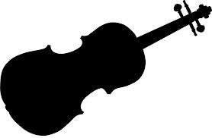
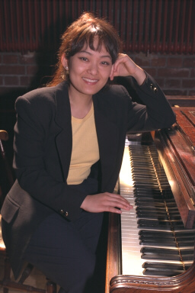
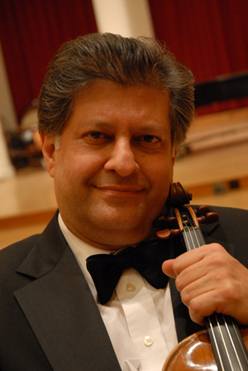

Cyrus Forough, violin Sung Im Kim, piano

October 4, 3:00 p.m.
James Laughlin Music Hall
Works by Leclaire, Ysaye, Franck, and Ravel

Admission: $20, $5 for students
Free for Chatham faculty and students

